Walking Route Map
To insert map, drag and drop in gray field below:

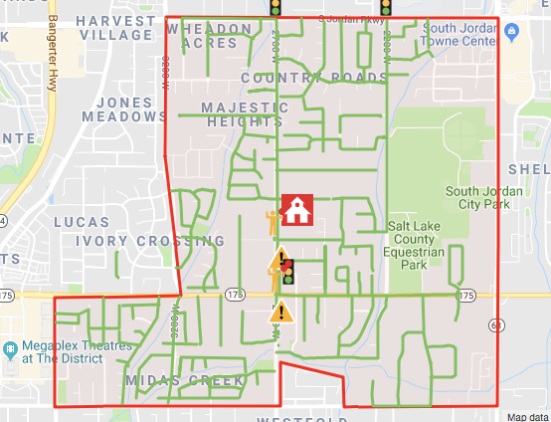
Approved: Principal Initials / Date ______________ Municipality/City Rep Initials / Date ______________

Municipality/City Rep Initials / Date ______________ Municipality/City Rep Initials / Date ______________
Approved: Principal Initials / Date ______________ Municipality/City Rep Initials / Date ______________

Municipality/City Rep Initials / Date ______________ Municipality/City Rep Initials / Date ______________

Text Description of Safe Routes
In this section, please divide your walking map into sections or zones and then provide a written description of the path students should take to walk to school. This description should accompany the visual map. Please highlight changes from previous SNAP plan.

Monte Vista Safe Walking Route:

1.) 10400 South - 11200 South (east of 2700 West) Students walk to 2700 West and then turn south and proceed to the school.
2.) 11200 South - 11400 South (north of 11400 South and east of 2700 West) Students walk northwest to 11400 South, turn west and proceed to 2700 West, turn north on 2700 West and proceed to the school.
3.) 11800 South - 11400 South (south side of 11400 South) Students walk north to 11400 South, then proceed west to 2700. They cross at the light and continue north to the school.
4.) 10400 South - Bison Ridge Road Students walk north to 10400 South, turn eas and proceed to 2700 West. They cross 2700 West, at the light and proceed south o the school.
5.) Area of 2700 West and 2865 West. Students walk south to 11400 South, then east to 2700 West, cross at the light with the crossing guard and then proceed to the school. Students have previously been routed to a pedestrian walkway connecting the streets aforementioned. The city of South Jordan does not maintain this walkway and has determined it to be hazardous. Students are encouraged to avoid this walkway, as it is no longer considered a safe walking route.
6.) 10890 South - Amina Way, west of 2700 West. Students walk south either Proudest Lane or Amina Way, then proceed south on 2700 West to the crossing guard and continue north to the school.
7.) 10400 South - 11800 South. Students walk north to the school.
8. 3200 West - 2700 West. Students walk east to 2700 West and walk either north or south to the nearest crossing guard. Cross at the light with the crossing guard to the east side of 2700 West and proceed to the school.
9.) 3420 West - 11400 South. Students walk northeast to the intersection of 11400 South and 2700 West, and cross at the light with the crossing guard to the east side of 2700 West, proceeding to the school.
10.) 2200 West - Culmination Street. Students walk south on Hemisphere Court to Meridles Drive, then east to Culmination Street. They proceed north to South Jordan Pkwy., then turn west and continue to 2700 West. They turn south on 2700 West and proceed to school.
11.) 2200 West - Plum Harvest Way. Students walk east on Amber Blossom Way to Plum Harvest Way. Then proceed to Plum Harvest Way until they reach South Jordan Pkwy. They turn west on South Jordan Pkwy. and continue to 2700 West. They turn south on 2700 West and proceed to school.
12.) Legend Creek Drive - proceed north to SJ Parkway on 2200 West. Turn west and continue to 2700 West. Turn south on 2700 West and proceed to school.

RECOMMENED WALKING ROUTE
1. Please review the walking route map with your child, and ensure that they follow the recommended route if they walk to school.
2. Cross only at intersections or marked crosswalks.
3. Use sidewalks if they are available.
4. Walk to and from school with a "buddy".
5. Walk bikes across the streets. Helmets and bike locks are a must!
6. Never play in canals or irrigation ditches, even if there is no water.
7. Respect private property as you walk to and from school.
8. Please walk straight to and from school. Do not stop and play along the way.

Approved: Principal Initials / Date ______________ Municipality/City Rep Initials / Date ______________

Municipality/City Rep Initials / Date ______________ Municipality/City Rep Initials / Date ______________
Approved: Principal Initials / Date ______________ Municipality/City Rep Initials / Date ______________

Municipality/City Rep Initials / Date ______________ Municipality/City Rep Initials / Date ______________

Loading / Unloading Access Zones Map

To insert map, drag and drop in gray field below:

