Hello Parents,

Welcome to 3rd grade! This is another exciting milestone in you and your child’s life and I am so happy to be a part of it. Included is information to help our school year start and run smoothly. Let the learning and adventures begin!

**Meet the Teacher**

This is my fifth year teaching 3rd grade at Monte Vista Elementary. I love this community. My husband and I live on a small “hobby farm” in West Jordan and I’ve had a great summer working through my never ending “To Do” list and raising a new puppy! We have a 2-year-old golden retriever, River, and a 4-month-old Golden Mountain Dog, Mabel.

**3rd Grade Daily Schedule (M-Th)**

Our class lines up on the GREEN dot behind the portables.

**9:00-9:10-** Morning Work

**9:10-9:55** Math

**9:55-10:30** Rotations

**10:30-10:45** Recess

**10:45-11:30** Math

**11:30-12:00** Walk to Read

**12:00-12:20** HD Word

**12:20-12:55** Lunch

**12:55-2:15** Reading

**2:15-2:45** Lexia

**2:45-3:30** Science/Social Studies

**3:30-3:35** Dismissal

**Communication**

The best way to reach me is through email. I respond quickly and will communicate with you frequently. I try my absolute best to keep communication with you consistent and individualized. Any lag in parent communication is due to planning and preparing to teach your children. Parent communication is extremely important to me.

* Blue Folders. Your child will receive a Monte Vista Blue Folderwhich will be taken home every day. All important paper communication from the school will be sent home in that folder. There may be some days when nothing is sent home in the folder but please consistently check and ensure your child takes it back and forth to school ***each*** day.
* Please call the office with any important ***day of*** messages or questions.
* Parent Teacher Conferences: October 2-3 and February 19-20.

**Donations**

Thank you in advance for your generosity to improve our learning environment.Please see my Back to School Donation List for ideas. Throughout the year I will also put suggestions in our monthly newsletter for donations/updates to my Amazon Wish List as well as any celebration items (donuts/pizza parties) we may need.

**BOB**

BOB stands for *Battle of the Books* and is a reading competition our school sponsors starting in 3rd grade. All students will be assigned a team and are required to read between 5-20 books up until the competitions in March. The book list is printed on the back of our monthly reading calendar as well as included here. Stay tuned for more information!

**Homework and School Work Expectations**

Homework for 3rd grade will include:

* 20 minutes Lexia (online reading program) 2x a week
* 20 minutes of Iready (online math program) 2x a week
* 10 mins minimum of daily reading (recorded on a reading calendar and turned in monthly)
* Any unfinished work from the school week

If your child does not have access to a computer at home, please let me know.

In **November**, **February**, and **May**, your student will be assigned AT HOME projects related to our Social Studies curriculum. This year 3rd grade will also put on a Wax Museum for parents/guardians in February. Please note this on your calendars and watch for more information coming.

We are going to have a wonderful year! I look forward to meeting you and being your child’s teacher this year.



Sincerely,

Mrs. Kump

Room #123

christeen.kump@jordandistrict.org

**Mrs. Kump Back to School Supplies Donation List**

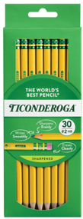The items on this list will be used during the regular school day. They may be brought from home on a voluntary basis; otherwise, they will be furnished by the school.

Whole Class Donations:



* Pre-sharpened pencils (Ticonderoga pencils are my favorite, but any brand is great except mechanical pencils.)
* Glue Sticks (No liquid glue)
* 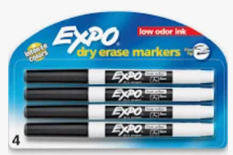Loose Leaf WIDE RULED paper
* 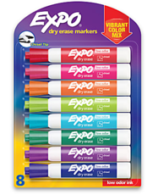Tissues with lotion (Costco)
* Clorox Wipes
* Hand Sanitizer (Only large bottles to place throughout the classroom)
* Ziplock Bags (sandwich and gallon sizes)
* EXPO Dry Erase Markers, Thin Tip (No other brands/color/size)
* 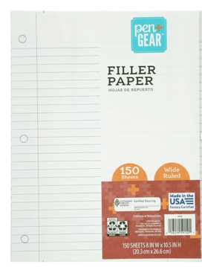EXPO teacher markers, vibrant color pack
* Page Protectors
* Notebook Dividers with Tabs
* Sticky Notes (regular size and small)
* Index Cards, unlined
* Headphones (The state provides the small black plastic ear buds for RISE testing, however they are not as comfortable for little ears.)

Supplies for your individual student (optional):

* 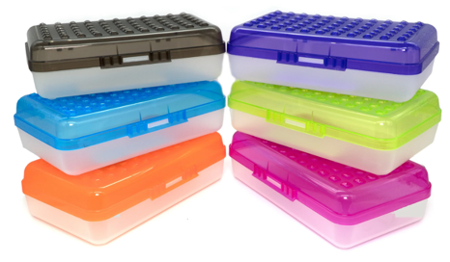Standard size pencil case
  + Art supplies may be brought in IF they fit inside pencil case.
* Pencil Sharpener
  + Students love to use colored pencils and I found this helpful last year.
* Headphones
* Old sock or rag (to be used as a whiteboard eraser)

*\*If any of these supplies are too big or too distracting, they will be sent home.\**

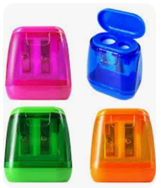

Supplies already provided in my classroom:

I may email throughout the year if we need additional donations of the following.

* Scissors
* Crayons
* Colored Pencils
* Markers
* Pencil Sharpener
* Personal whiteboard
* Playground supplies (Foursquare balls, basketball, soccer ball, football, softball/bat)
* Prize box toys and treats

*Amazon Wishlist: <https://www.amazon.com/hz/wishlist/ls/PKIOW326Z6LW?ref_=wl_share>