Dear Families,

An exciting year is about to begin!! We welcome your child to the third grade! We are looking forward to meeting them.

English Teacher:

My name is Mrs. Natalie Stanworth and I will be your student’s reading, writing and social studies teacher. This will be my twelfth year teaching and my third year teaching third grade at Monte Vista. My husband and I will be celebrating our 27th Anniversary this fall. My son Hunter is 22 and will be graduating from the U with his masters in the Spring. Last year my daughter Emmeline graduated High School and she will begin nursing school soon. As a family we enjoy going to concerts and playing with our three Bassett Hounds; Penny, Ruby, and Mini (who is 10 weeks old and loves to run away and chew on everything). My favorite activities are reading and building with Lego’s. I love teaching children and seeing how excited they get while learning! I look forward to getting to know you and your child this year!

[Natalie.stanworth@jordandistrict.org](mailto:Natalie.stanworth@jordandistrict.org)

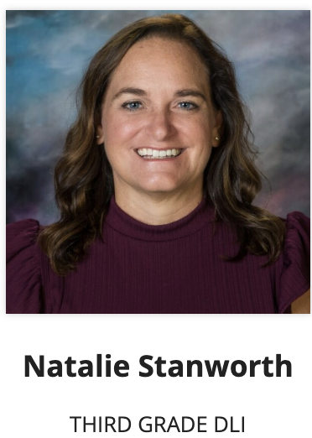

Chinese Teacher:

My name is Mrs. Grover, also known as Ms. Lee. I am from Taiwan. I’m honored to be your child’s 3rd grade, Chinese dual immersion teacher, this year. I love to grow with my students.

Please read the information below and feel free to contact us if you have any questions. Email : Yvonne.grover@jordandistrict.org



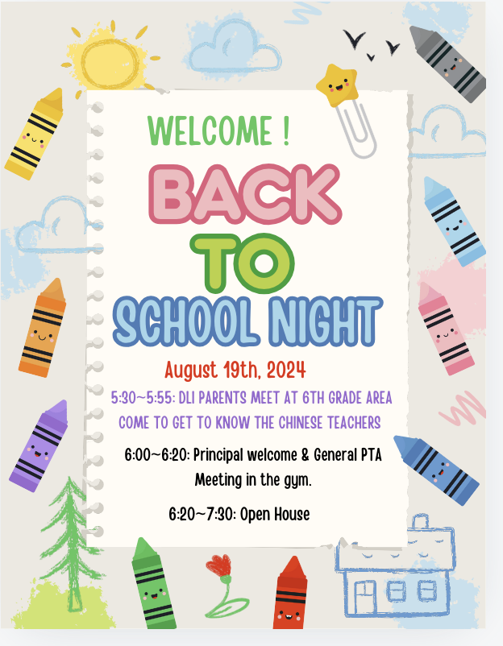

**Chinese Homework:**

All homework assignments from the Chinese class will be posted in the Modules in Canvas weekly. Mandarin Matrix Passwords and usernames will be given when it is ready.

**Math Homework**

Students will be given math worksheets and turn in with the blue folders.

* **Chinese Homework**

**\* (A) Quizlet**: The students are expected to complete 2 sections as follows

in Quizlet by the due date ( The details will be described in Canvas Modules). The required 2 sections are:

1st week: complete **Flashcard**

2nd week: complete **Match**

**\* ( C) Reading:** The students are expected to spend 5~10 minutes each night 5 days a week reading Chinese printed in the reading sheets to parents and answering a few questions listed on the reading sheet.

\***(D) Mandarin Matrix**: The students are expected to complete Mandarin Matrix

**\* ( E) Recording:** The students are expected to record the sentence posted in Canvas Modules .

**\*(F..<) Chinese worksheet**: Students will be assigned the worksheet every 3rd week. Students need to complete it and turn it in with the blue folders.

**Quizzes/tests**

**\*** There will be a quiz every Friday.

**\*** There will be a lesson chapter test at the completion of each lesson/chapter.

**>>>>>>>>>>>>>>>>>>>>>>>>>>>>>>>>>>>>>>>>>>>>>>>>>>>>>>>>>>>>>>>>>> English Homework**

**\* (A) Reading:** Your student will be required to read every night for 20 minutes - 5 days a week. Calendars will be sent home each month to track minutes. Each student will be part of a team that competes in Battle of the Books (BOB) . They will be assigned about 4 books to read and will be able to answer questions about each book. If your child reads all 20 books they will be honored in the 20 club and go on a school wide really fun field trip!

**\* (B) Math:** Your student will be required to work on math facts 5 minutes - 5 days a week. I believe that consistency pays off.

**\* (C) Other Homework:** There may be other homework given as needed.

**Quizzes/tests**

**\*** There will be tests and other assessments given during each reading module.

**\*** Every Friday we will have a spelling test. Spelling tests will show your child’s knowledge of the spelling patterns taught that week. There will not be a list of words sent home that the students will study from. I will be sending home learning activities that will help them master the Spelling Patterns.

**Blue folders will be given on Monday and turned in the next following Monday.**

**Classroom rules (also known as our schools Mustang 5)**

1. Follow adult directions the first time.

2. Keep hands, feet, objects and harmful words to yourself.

3. Respect myself, adults, peers and property.

4. Be prepared.

5. Be where you are supposed to be.

**Behavioral Rewards:**

**●** Tickets/Class money will be given out for following the Mustang 5 rules.

**●** A class store will be “open” every few months. This is a time for your student(s) to spend their tickets. Your student may bring in items to sell for the store. This is optional.

**Behavioral Consequences:**

Failure to follow class rules will result in:

1st A verbal warning. After a verbal warning, the student will give the teacher a ticket/class money for not following the rules. If further action is needed, parents will be informed.

● Your student may be asked to stay in during recess to complete unfinished work. If this is a problem, please contact us via email.

Items that students need on the first day of school:

**Mrs. Grover’s class**

* A white board eraser for Chinese class.(Or old socks work well, too
* Three black, thin, dry erase marker pens.

**Mrs. Stanworth’s Class**

* Three black, thin, dry erase marker pens.
* 1 inch white binder with a clear pocket on the cover (this will be used as our Wit and Wisdom Journal).
* 10 page protectors
* 5 divider tabs that will go in the binder
* Small pencil box
* Ear phones for students' personal use in both classes, not earbuds.

Please let us know if you will be unable to bring these items and we will provide them for your child.

As a class we will share all pencils, scissors, markers, crayons, and glue sticks. If you would like to donate these items, we would be very grateful!

**Supplies for the whole class (these are things needed all year long)** Kleenex, band aids, Clorox wipes and hand sanitizer.

Schedule

9:55 Rotation

10:30 Recess

12:20 Lunch & recess

Sun Class Homeroom is Mrs. Stanworth

Moon class Homeroom is Mrs. Grover

*On the first day of school students will start in their homeroom.

Thank you,

Mrs. Grover (Ms. Lee)

Mrs. Stanworth

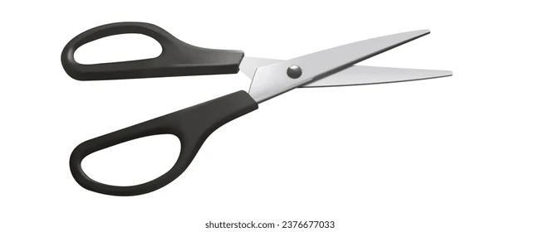<<<<<<<<<<<<<<<<<<<<<<<<<<<<<<<<<<<<<<<<<<<<<<<<<<<<<<<<<<<<<<<<<<<<<<<<<<<<<<<<<<<<<<<<<<<<<<<<<<<

I have read and talked about this with my child.

______________________ ____________________

Parents name Student’s name