**Schedule**

8:55 Arrival/Morning Work

9:10 Walk to Read

9:40 Math

10:25 Recess

10:40 Rotations

11:15 Wit & Wisdom

12:00 Science/Social Studies

*Switch Classes*

12:30 Lunch

1:05 Morning Work

1:15 Math

2:00 Wit & Wisdom

2:45 Science/Social Studies 3:10 Reading 3:35 Dismissal

**Areas of Study**

Language Arts:

Fluency

Comprehension

Writing

Grammar

Phonics

Vocabulary

Math:

Place Value

Multiplication

Division

Measurement

Fractions

Decimals

Geometry

Science:

Structure and Function

Fossils

Energy Transfer

Wave Patterns

Patterns in the Sky

Social Studies:

Utah Geography

Utah History

Counties of Utah

4th Grade



Mrs. Tarpenning

dionne.tarpenning@jordandistrict.org

**Rules**

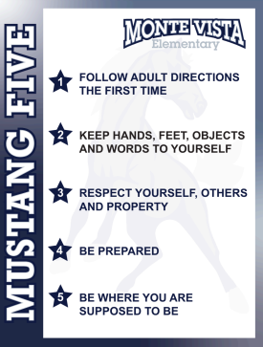

In our class and throughout the school, we will follow the Mustang Five.

**Other Rewards**

Tickets awarded for behavior and accomplishments to be used during quarterly class store

Rotations rewards

Students who break class rules will have consequences as listed on the chart in our classroom.

**Homework**

**Weekly homework: 1 math page to review what is taught that week**

**Read 30 minutes** each day (students are encouraged to read from the Battle of the Books list)

Fill out the reading calendar.

If students read at least 20 minutes a day, a reward is given at the end of the month.

**Multiplication fact practice** Students will pass off multiplication & division facts.

A reward is given at the end of multiplication and division if completed by the end of December.

**Projects** 1 each month: Animal Report, County Report, Famous Utahn, Personal Timeline, All About a Character, Comic Book, Utah Report, and Math Fair

**Water/Snacks**

Students should bring a full, spill-proof water bottle each day.

Water only- no other drinks.

Students may bring a snack, but we do not take a break for snacks. These must be consumed quietly and inconspicuously.

No food outside.